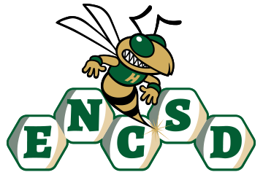
School Rules
Policy 2475

Purpose
The Eastern North Carolina School for the Deaf (ENCSD) Board of Trustees recognizes that clear, consistent, and accessible school rules are essential to maintaining a safe, orderly, and supportive learning environment. This policy establishes the authority and expectations for the development, communication, and enforcement of school rules in alignment with applicable federal and state laws.

I. Policy Statement
ENCSD shall establish and enforce school rules that promote student safety, positive behavior, respect for other, and an environment conducive to learning. School rules shall be reasonable, age-appropriate, clearly communicated, and applied fairly and consistently, while respecting the rights of students.

II. Authority to Establish School Rules
- The Superintendent or designee is authorized to establish school rules consistent with Board policies and applicable laws.
- The principal may develop and implement school rules as necessary to support safe and effective school operations, provided such rules align with Board policy and Superintendent-issued administrative procedures.
- School rules shall not conflict with Board policies, administrative procedures, or legal requirements.

III. Communication and Accessibility of School Rules
- School rules shall be communicated to students, parents, guardians, and staff in a clear and accessible manner.
- Rules shall be made available in formats accessible to Deaf and hard of hearing students and families, including but not limited to:
  - Visual and plain language formats
  - ASL or other sign language supports
  - Captioned or accessible digital content
- Reasonable accommodations and auxiliary aids and services shall be provided to ensure effective communication, consistent with the ADA, Section 504, and IDEA as applicable.

IV. Enforcement of School Rules
- School rules shall be enforced fairly, consistently, and in a manner that respects student rights.
- Students shall not be disciplined for behavior that is a direct result of a disability or communication barrier, consistent with IDEA and Section 504 requirements.
- Disciplinary responses to violations of school rules shall align with Board policies related to student discipline and due process.

V. Review and Revision
- School rules shall be reviewed periodically to ensure effectiveness, fairness, and legal compliance.
- The Superintendent shall ensure that school rules are updated as needed to reflect changes in law, Board policy, or school needs.
- Stakeholder input may be considered during the review process, using accessible communication methods.

Legal References
- North Carolina General Statutes §§ 115C-47, 115C-390 et seq.
- Individuals with Disabilities Education Act (IDEA), 20 U.S.C. § 1400 et seq.
- Section 504 of the Rehabilitation Act of 1973, 29 U.S.C. § 794
- Americans with Disabilities Act (ADA), 42 U.S.C. § 12101 et seq.
- North Carolina State Board of Education Policies related to student conduct

