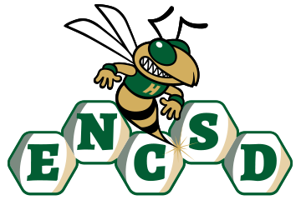
Board of Trustees

Public Notice of Proposed Policy for Comment
Eastern North Carolina School for the Deaf invites public comment on the following proposed policies. In accordance with applicable state law, policies are posted for stakeholder review and feedback prior to adoption by the Board of Trustees.
Policy Title/Number
Professional and Staff Development 1610/7800
Summary of Policy
The proposed policy establishes expectations and procedures for professional and staff development at ENCSD, including:
- A clear definition of professional development, licensed staff, non-licensed staff, and Continuing Education Units (CEUs).
- Required participation in ongoing professional learning for all employees as a condition of employment.
- Alignment with NCDPI licensure renewal requirements, OSHR performance standards, and compliance obligations (e.g., FERPA, ADA, OSHA).
- Required professional learning for licensed staff in areas such as:
  - Instructional practices and digital learning
  - Equity and inclusive practices
  - Deaf education, Deaf culture, and ASL proficiency
- Required staff development for non-licensed employees focused on job performance, safety, communication, and Deaf awareness.
- A structured ASL development plan for staff who are not fluent in ASL.
- Annual completion of mandatory compliance training, including child abuse reporting, civil rights, data privacy, workplace safety, and staff-student relations.
ENCSD is committed to ensuring that all parents and guardians, including those who are Deaf or Hard of Hearing, have disabilities, or have limited English proficiency, can meaningfully engage with the school. All notices, policies, and opportunities for participation will be provided in accessible formats and languages, consistent with ADA, Section 504, and federal guidance.
How to Submit Comments
Please submit written comments via email to: mandy.armstrong@encsd.k12.nc.us
Or mail to:
Eastern North Carolina School for the Deaf
Attn: Mandy Armstrong
1311 US-301 South
Wilson, NC 27893
Deadline for Comments:
All comments must be received by February 16, 2026, 12 PM to be considered by the Board.

