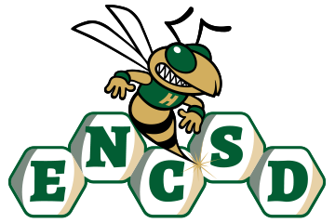
Board of Trustees

Public Notice of Proposed Policy for Comment
Eastern North Carolina School for the Deaf invites public comment on the following proposed policies. In accordance with applicable state law, policies are posted for stakeholder review and feedback prior to adoption by the Board of Trustees.
Policy Title/Number
Remote Learning 3061
Summary of Policy
This policy establishes a framework to ensure continuity of instruction during inclement weather, emergencies, or other circumstances that prevent in-person attendance. It outlines how ENCSD will provide accessible, equitable, and high-quality learning opportunities in compliance with North Carolina Department of Public Instruction (NCDPI) guidance and state law.
Key provisions include:
- Purpose and Implementation: Remote learning may be activated during unsafe travel conditions, public health concerns, facility issues, or other emergencies as determined by ENCSD or state authorities.
- Instructional Methods: Remote learning may be synchronous (live, real-time instruction) or asynchronous (flexible, self-paced learning) to meet student needs and ensure accessibility.
- Accessibility: All instructional materials will be fully accessible to deaf and hard of hearing students, including captioned videos, ASL interpretation, and visual supports.
- Student Support: ENCSD will provide devices, internet access assistance, and technical support to ensure all students can participate effectively in remote learning.
- Special Education Services: Students with IEPs will continue to receive accommodations, modifications, and related services through coordinated support from teachers and service providers.
- Staff Responsibilities: Teachers and administrators are responsible for maintaining communication, documenting engagement, and ensuring all learning remains accessible and effective.
- Evaluation and Review: The policy will be regularly reviewed based on feedback from students, families, and staff to maintain compliance and continuous improvement.
The policy reflects ENCSD’s commitment to student safety and upholding the highest standards or professional conduct. It aligns with applicable state and federal laws as well as NCDPI guidelines.
How to Submit Comments
Please submit written comments via email to: mandy.armstrong@encsd.k12.nc.us
Or mail to:
Eastern North Carolina School for the Deaf
Attn: Mandy Armstrong
1311 US-301 South
Wilson, NC 27893
Deadline for Comments:
All comments must be received by December 16, 2025, 12 PM to be considered by the Board.

